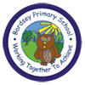
W/C: 13/07/2020 Learning Project - TRANSITION
Age Range: Year 4
This week’s learning project focuses on supporting your child with transitioning to their new class.
It will give them the opportunity to reflect on their time in their current class, discuss their favourite memories and achievements whilst also considering their hopes and dreams for the next academic year.
Transition Activities
MEMORIES | Monday- Starting a new academic year is a time for your child to say farewell to current teachers and classmates and hello to many new faces. It is important for your child to cherish their favourite memories. Ask your child to create a drawing or art piece of their special memory and frame it in a hand-made photo frame. They may choose to draw a favourite lesson, a funny moment with friends, a school trip, their favourite teacher or a job role they were proud of. They may choose to decorate the photo frame provided or to craft their own using card. Click here for photo frame ideas. Share at #TheLearningProjects.
ACHIEVEMENTS | Tuesday- Every child is unique and special. Over the course of the last year, your child will have achieved so much. Whether that’s learning their times tables, swimming without armbands or having the confidence to put their hand up in class and offer an answer. Remind your child that an achievement is something that has been accomplished through great effort, skill, perseverance or courage then ask them to mind map all of their achievements this year, both in school and outside of school. Look at the mind map together and ask your child to identify their greatest achievement? Encourage your child to write about this special achievement. How did they accomplish this? What barriers did they face? Who helped them? They could record this as a story featuring themselves as the main character, a newspaper report or even write a rap!
SAYING FAREWELL | Wednesday- Ending the academic year can be a time that is full of mixed emotions for many children. However, whilst many aspects of school life change, many remain the same too. Spend some time with your child discussing all of the similarities and differences between their current class and the new class that they will be going into. For example, their lunchtime may remain the same or they will now get to learn how to play the ukulele. Following this, ask your child to record the similarities and differences using the table below.  A new year is also a great time to make new friends. Can your child create a poster that illustrates top tips for making friends and showing kindness? They could speak to family members or their own friends to gather some ideas first.
INDIVIDUAL QUALITIES | Thursday- Art can be a great tool for self-exploration and self-expression. Encourage your child to create a piece of artwork which represents their personality and highlights their individual qualities. This could be a picture or something more abstract using materials available at home. Your child may find listening to their favourite music encourages their own expression. Once completed, ask your child to discuss their artwork with you. What did they want to represent in this piece? How did they try to show off their personality through their artwork?
GOAL SETTING | Friday- Setting goals is an excellent way for your child to try and achieve things that they might not think is possible. Goal setting will also help your child to improve their confidence and self-esteem when they see that they can achieve the target they’ve set. Create a ‘Wheel of Fortune’ together (see below). Use the headings: Learning, Friendships, Physical Challenge, Wellbeing and Family. Under each heading, ask your child to write a goal thinking carefully about how long it will take to achieve each goal, who or what can help them and any difficulties they may have to overcome.
#TheLearningProjects

Year 1 to Year 5- Transition Learning Project
Below are some ideas of how your child could set out their work.
MEMORIES | ACHIEVEMENTS | SAYING FAREWELL | INDIVIDUAL QUALITIES | GOAL SETTING
 |  | 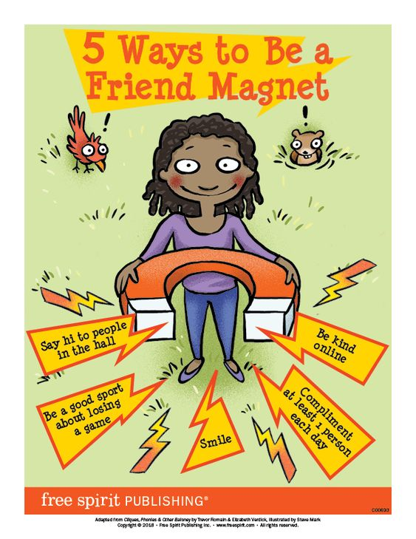 | 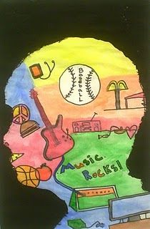
Additional Learning Resources Parents May Wish To Engage With:
- Tips and resources to support transition from Mentally Healthy Schools can be found here.
- Childline wants to help bring out the best in your child through some easy-to-do activities.
- The BBC Bitesize website has lots of helpful videos to support transition for both parents/carers and children.
- Parentkind provides handy hints to help prepare your child for their new class.
#TheLearningProjects

