Learning Goals: I can retrieve information from a text and infer how a character is feeling.  confused, stir, gentle, blaze | 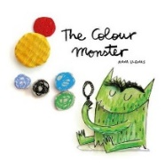  Independent Paired work  Group work Supported  Verbal  Feedback
Gold
Fiction – The Colour Monster
- Why is the Colour Monster feeling mixed up and confused at the start of the story?
___________________________________________________________________________

___________________________________________________________________________
- How can sadness make you feel?
_____________________________________________________________________

_____________________________________________________________________
- How do you think the Colour Monster feels at the end of the story when he is pink?
_____________________________________________________________________

_____________________________________________________________________
- Choose one of the colours and draw the Colour Monster feeling this way. In the speech bubble, write how he feels.
________________________________________

Gold

L.O: To write sentences about your feelings.
My turn:
happy
I feel happy when I go shopping in Leeds with my lovely friends and buy something new.
Your turn:
upset

excited

annoyed

Lesson 2 – In the jar below, choose a feeling. Draw all the things that make you feel this way. Write sentences about your chosen feeling underneath. Try to use two adjectives together to describe different things in your jar.

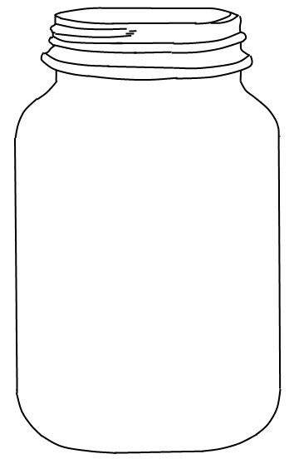

Gold

Silver
Learning Goals: I can retrieve information from a text and infer how a character is feeling.  confused, stir, gentle, blaze | 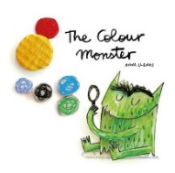  Independent Paired work  Group work Supported  Verbal  Feedback
Fiction – The Colour Monster
- Why is the Colour Monster feeling mixed up and confused at the start of the story?
The Colour Monster is feeling mixed up and confused because _____________

___________________________________________________________________

- How can sadness make you feel?
Sadness can make you feel ____________________________________________

- How do you think the Colour Monster feels at the end of the story when he is pink?
I think the Colour Monster is feeling _____________ because

______________________________________________________________
- Choose one of the colours and draw the Colour Monster feeling this way. In the speech bubble, write how he feels.
I feel ___________ because
______________________________

Silver
L.O: To write sentences about your feelings.
My turn:
happy
I feel happy when I go shopping in Leeds with my lovely friends and buy something new.
Your turn:
upset
I feel upset when

excited
I feel excited when

annoyed
I feel annoyed when

Silver
Lesson 2 – In the jar below, choose a feeling. Draw all the things that make you feel this way. Write sentences about your chosen feeling underneath. Try to use an adjective to describe each thing in your jar.

Bronze
Learning Goals: I can retrieve information from a text and infer how a character is feeling.  confused, stir, gentle, blaze | 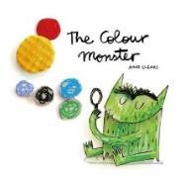  Independent Paired work  Group work Supported  Verbal  Feedback
Fiction – The Colour Monster

- Why is the Colour Monster feeling mixed up and confused at the start of the story?
- How can sadness make you feel?
- How do you think the Colour Monster feels at the end of the story when he is pink?
- Choose one of the colours and draw the Colour Monster feeling this way. In the speech bubble, write how he feels.

1. The Colour Monster is feeling mixed up and confused because
he isn’t feeling well. | 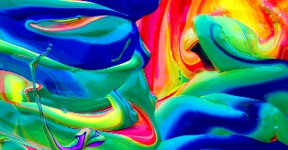  his feelings are stirred together. | 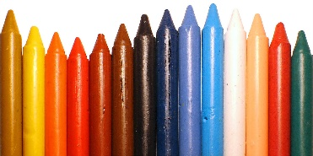  he can’t find his colours.

2. Sadness can make you feel
bright and light. | like you want to stomp. | alone and it makes you cry.
3. I think the Colour Monster is feeling
_____________________________________

Word Bank
happy | sad | angry | calm | loving

Choose one of the colours and draw the Colour Monster feeling this way. In the speech bubble, write how he feels.
I feel ___________

Lesson 2 – In the jar below, choose a feeling and draw all the things that make you feel this way. Label each picture using your phonics.

Bronze

