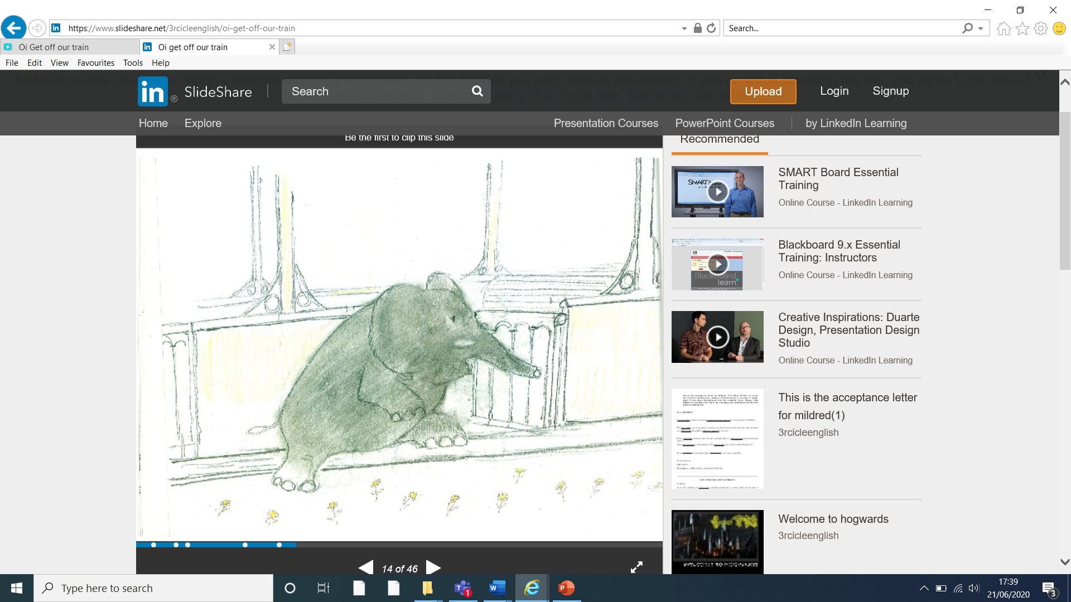

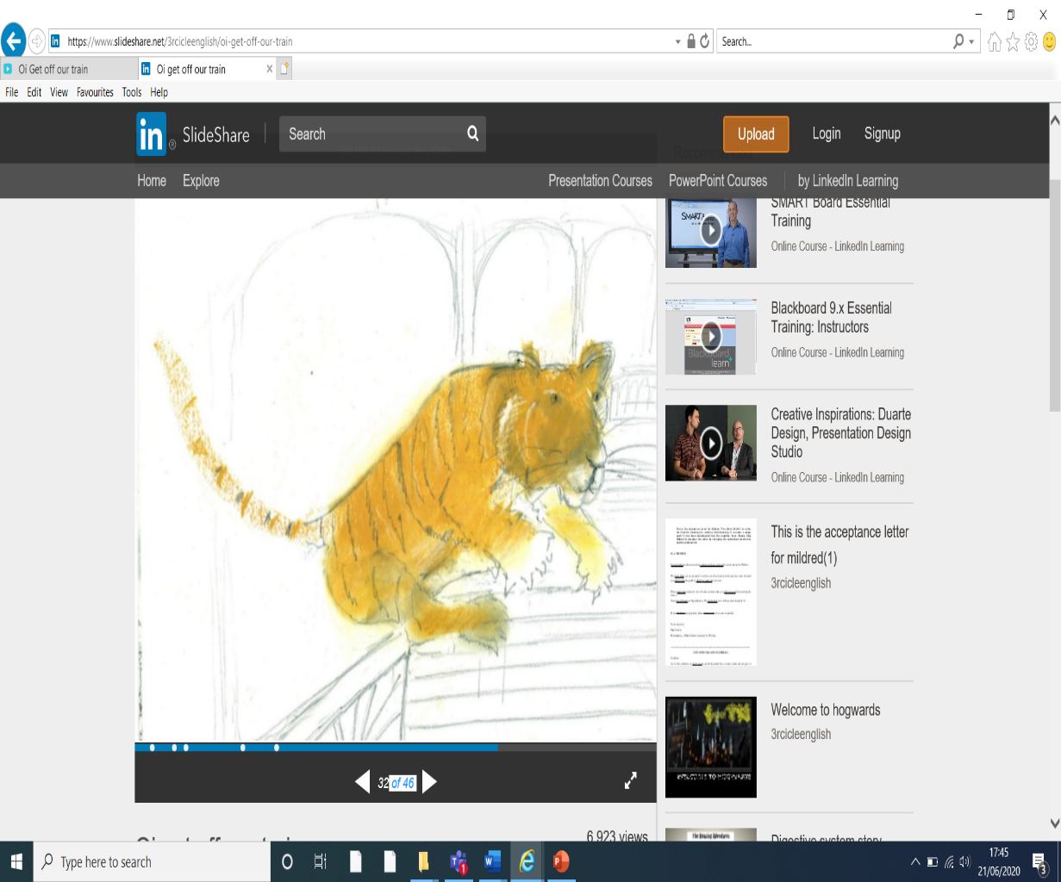

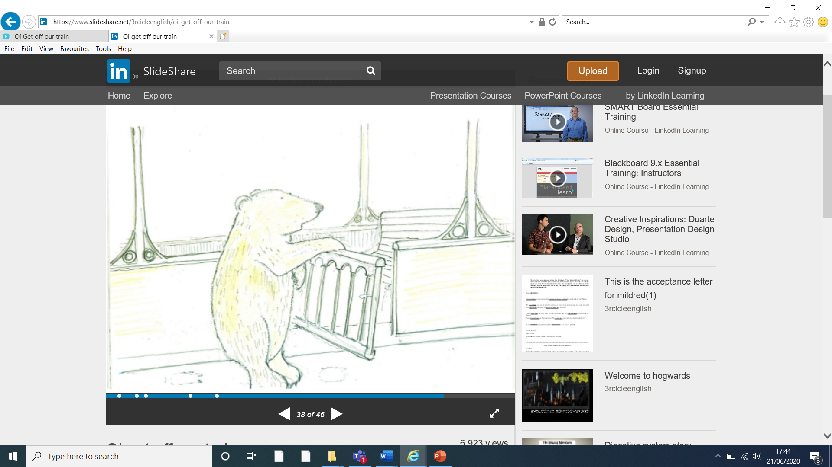

|  |  |  |
| --- | --- | --- |
| **L.O: To write persuasive sentences.** | **parent** | **me** |
| See the source imagecapital letters |  |  |
| See the source imagefull stops |  |  |
| conjunctions (and, but, or, if, because, so) |  |  |
| cause and effect |  |  |