Hi Year 4. Here are some tasks you can be doing at home either independently or with your family. I have created a code breaker challenge (in files) and a range of other worksheets that you can use if you do wish for different subjects. I hope you are all keeping safe and looking after your family. I miss you all. Hope to see you soon, Mr Hackworth.

Parents -

Learning Project WEEK 2 - My Family
Age Range: Y4
Weekly Maths Tasks (Aim to do 1 per day) | Weekly Reading Tasks (Aim to do 1 per day)
● Working on https://www.timestables.co.uk/multiplication-tables-check/ practise your multiplication check scores  ● Play on Hit the Button - focus on  number bonds, halves, doubles and  times tables.  ● Adding totals of the weekly shopping list  or some work around money. This  game could support work on adding  money.  ● Practise telling the time. This could be  done through this game (scroll down to  access the game). Read to the quarter  hour and the nearest 5 minutes.  ● Get a piece of paper and ask your child  to show everything they know about  Addition. This could be pictures,  diagrams, explanations, methods etc.  They can be as creative as they want to  be.  ● Practise counting forwards and  backwards from any given number in  different tables. | ● You could share a story together. This  could be a chapter book where you read  and discuss a chapter a day.  ● Listen to your child read and let them  discuss what they have read.  Encourage them to read with  expression and intonation.  ● Watch Newsround and discuss what is  happening in the wider world.  ● Get your child to read a book on Oxford  Owl, discuss what your child enjoyed  about the book.  ● Get your child to read a book on Active  learn and complete the activities. These  focus on comprehension skills.  ● Explore new vocabulary you find when  reading. What are the origins of this  word? Can it be modified? Can you find  any synonyms or antonyms for your  new word?  ● With your child, look in magazines,  newspapers and books for new  vocabulary they are unfamiliar  with. They could use a highlighter to  highlight in magazines and newspapers then write these words in their handwriting book that was sent home last week.
Weekly Spelling Tasks (Aim to do 1 per day) | Weekly Writing Tasks (Aim to do 1 per day)
● Practise the Year 3/4 for Common  Exception words.  - Use Spellodrome to practise spelling.  ● Practise your spelling on Spelling Shed  ● Practise your spelling on Spelling  Frame  ● Choose 5 Common Exception words.  Write synonyms, antonyms, the  meaning and an example of how to use  the word in a sentence. Can the word  be modified?  ● Choose 5 Common Exception words  and practise spelling them using  forwards backwards. Write the word  forwards then write the words  backwards, e.g. forwards sdrawrof | ● Write a recount of your day. This could  be used in history one day to show what  happened during this period.  ● Write a character description of a  member of their family. What do they  look like? How do they behave? etc...  ● Write a story involving members of their  family. Do they have to defeat a  monster? or find something they have  lost?  ● Write a set of family rules, could they  begin with ‘We always…..’ rather than  ‘We do not ………’  ● Write a letter/email/ text message to a  member of their family that they have  not seen this week.  ● Take part in a writing master class.

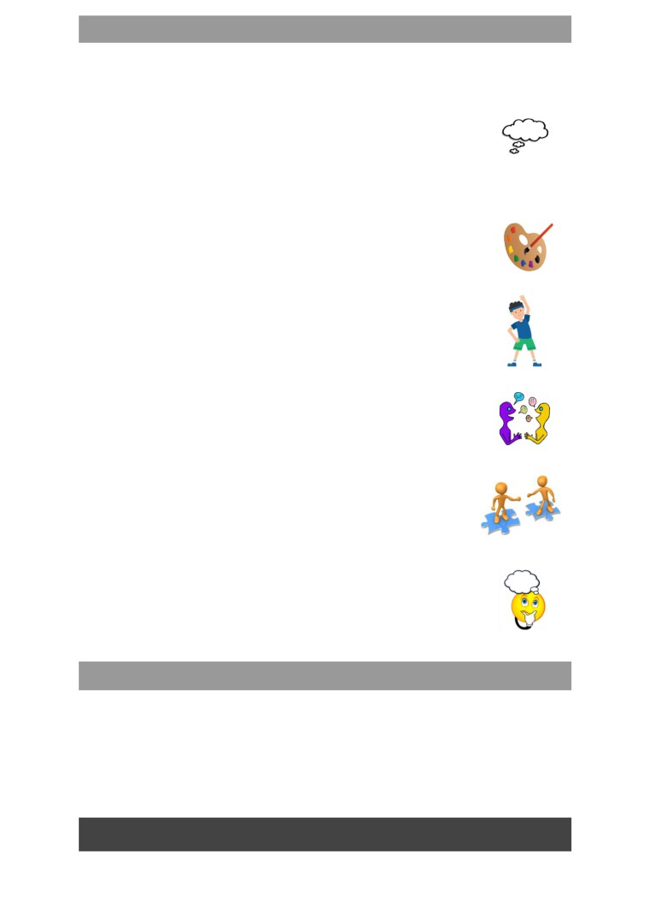

Learning Project - to be done throughout the week
The project this week aims to provide opportunities for your child to gain a better
understanding of their own family. Learning may focus on what different makeup of families,
what traditions your family has, stories linked to your family etc.

● Let’s Wonder:

Who is in your child’s immediate family? What other relatives do they have?
How does their family link together? How many people do they have in their
family? Why not spend time looking through old photos and talking about
the people in their families. What family stories can they tell? How is life different to their
parents? grandparents?

● Let’s Create:

Create a piece of artwork entitled ‘Family’. This could be a drawing, a self
portrait, a sculpture or collage. Could they copy another artist's style?
Which materials have they chosen to use and why? How do they feel about
their piece of artwork? What would they change or not? Family portraits.

● Be Active:
Daily PE with Joe Wicks on his Youtube Channel at 9am (Parents too!!) https://www.thebodycoach.com/blog/pe-with-joe-1254.html
Go Noodle with the family or have a family workout. Fancy a dance? There
are lots of dance videos they could try. Dance. Maybe try some Yoga.
Recommendation at least 2 hours of exercise a week.

● Time to Talk:

Perhaps they could play a board game, Facetime a member of their family
they have not seen this week, enjoy a family indoor picnic or have a family
dinner. Why not catch up with friends using House Party or Zoom apps.

● Understanding Others and Appreciating Differences:

Discuss how their family is different to other people’s families. Discuss
whether all families are the same? Does it matter? Do all families
have the same faith? Do all families worship in the same way?

● Reflect:

Find out what music their family members enjoy. Do they like the same
music? What is their favourite song? They could listen to different pieces of
music together with their family. Do they like/dislike any particular types of
music and why? Can they Identify the instruments they can hear and
describe how the music makes them feel? Charanga online is free to use and is a resource we use in school.

Additional learning resources parents may wish to engage with
Classroom Secrets Learning Packs - These packs are split into different year groups
and include activities linked to reading, writing, maths and practical ideas you can do
around the home.
Twinkl - to access these resources click on the link and sign up using your own email
address and creating your own password. Use the offer code UKTWINKLHELPS.
Headteacherchat - This is a blog that has links to various learning platforms. Lots of
these are free to access.
Do what you like, when you like and stay safe, many thanks, Mr Hackworth.

