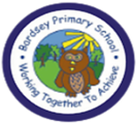
W/C 6.07.2020: Learning Project - Celebrations
Age Range: EYFS
Weekly Reading Tasks | Weekly Spelling Tasks
Monday- Watch the story of Kipper's Birthday here. Ask your child to talk about the problem in the story. How did Kipper feel? | Monday- Your child can practice reading and listening to sounds by playing Odd Sound Out or practise reading their Tricky Words.
Tuesday- Find old celebration cards, perhaps from past birthdays or religious celebrations, and share them with your child. Talk about the features of the cards e.g. who it is to who, poems/verses, pictures of cakes, etc. | Tuesday- Write a variety of sounds on balloons (or paper). Place the balloons around a room. Say words associated with celebrations e.g. cake and ask your child to identify the initial sound by running to the balloon that represents the sound.
Wednesday- Listen to the story of the Scarecrow’s Wedding here. Ask your child to recount the important events from the story. | Wednesday- Role play a celebration event of your child’s choice. This will support your child’s speaking and listening skills.
Thursday- Ask your child to look at the books you have in your house. Can they find any books which reference celebrations e.g. The Snowman. Read the story to your child, encouraging them to join in with familiar phrases. | Thursday- Learn the song ‘On Bonfire Night’ and encourage your child to make marks to represent the sounds in the song e.g. whiz, whiz could be a swirling pattern.
Friday- Reception age children: Children to read to parents daily. Visit Oxford Owl for free eBooks that link to your child’s book band. Complete the Play Activities. | Friday- Watch this fireworks display video. Can your child make their own imitation of firework sounds? They could use pots, pans or any other household object.
Weekly Writing Tasks | Weekly Maths Tasks- Time and Money
Monday- Watch a children’s film with a celebration in e.g. Cinderella, Rio or Shrek.  Following this, ask your child to draw the most important events from the story in order. Can they write simple sentences about each picture? Or can they label each picture with one word using their phonics knowledge? You could even ask your child to retell the events from the film in their own words. | Monday- Play shops with your child. When they are the customer say things such as “That is £3 please.” , “You haven’t given me enough, can I have some more money please?”. When they are the shopkeeper ask them things such as “How much is this?”, “Do you need more money?”, “Can you give me my change please?”. In doing this, they get used to hearing language associated with money.
Tuesday- Encourage your child to draw a picture of a celebration that they have taken part in or of a special time in their life. They could use their phonics knowledge to write about their memory of that day. Talk to them about their feelings during the day encouraging them to use vocabulary such as excited, cheerful, jolly. | Tuesday- Get a selection of 1p coins and talk to your child about these coins being 1 penny. Collect some items from around the house or treats they can eat and label them 1p, 2p, 5p and possibly 10p. Ask your child to pick an item, but before giving it to them they need to give you the correct number of pennies based on the amount on the label. E.g. if it was 2p they would have to hand you two pennies.
Wednesday- If you could give any gift, to anyone, what would it be and why? Discuss this question with your child and then ask them to draw a picture of their gift of choice. Can they have a go at writing the recipients’ name? Can they write their name to show who the gift is from? | Wednesday- List or draw things that your child will do during the day on pieces of paper. Can your child order the things they do during the day? Use the language first, then, next and later to help. You could make a visual timetable of some of the things you will be doing tomorrow and write ‘First you will…’, ‘Then you will….’, etc. CHALLENGE: Try and encourage your child to use the words before and after an event in the day.
Thursday- After your child has listened to the Fireworks Song (see above), ask them to list words to describe what the fireworks look and sound like. They might want to design a firework safety poster too. | Thursday- Ask your child to complete tasks in a certain time and you/family members do the same tasks e.g how many star jumps can you do in a minute? Pick the toys up in less than 30 seconds? Who was fastest? Who got the most?
Friday- Talk to your child about their personal achievements. What are they most proud of and why? Can they make themselves a certificate to celebrate? They could use materials from around the house to create this. | Friday (theme)- Make a selection of birthday cards with numerals on the front. Can your child count out birthday candles (if you have them) or objects to match the amount? Can they order the numerals from the smallest amount to the largest?

Learning Project - to be done throughout the week
This project this week aims to provide opportunities for your child to learn more about celebrations. Learning may focus and different types of celebrations that take place and who may celebrate them. It could look at how people celebrate different events differently in other parts of the world.

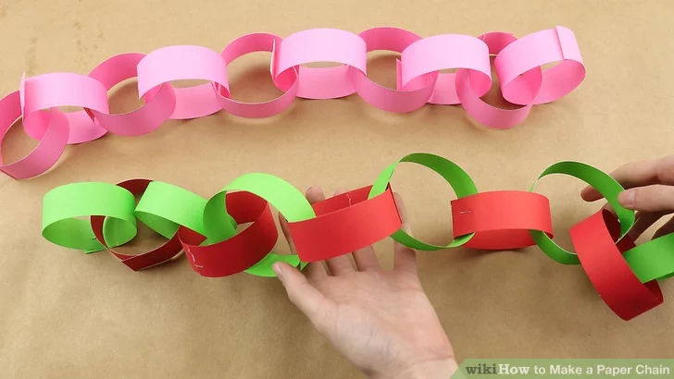
- Family Photographs- Look over a selection of photographs of family celebrations and discuss with your child: what the celebration was about, who attended, what you did to celebrate, when it took place, whether it is an event that happens each year. Can your child remember the event taking place? What do they remember about it? They could draw a picture to illustrate their favourite memory of the day. If you have access to a PC, this could be done on a drawing program such as Paint.

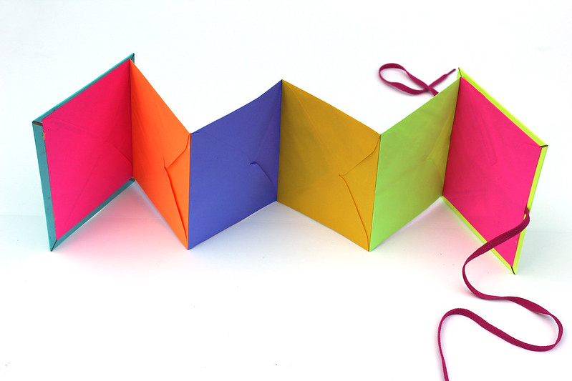
- Plan a Family Celebration- Decide on a family celebration for the week. This could be a family indoor picnic, meal, dance etc. Ask your child to write invitations, inviting those that they live with to the party. Your child could also create homemade decorations using coloured paper (if you do not have coloured paper at home, you could use old newspaper or wrapping paper). They could make paper chains or bunting too. Share your family celebration with me by sending me a video or uploading to Tapestry.

- Discover Religious Celebrations- Watch the ‘Let’s Celebrate’ video collection for Easter. Discuss the celebrations with your child. Did they celebrate Easter this year? Which of the events did they take part in? Then watch the ‘Let’s Celebrate’ video collection for Eid-al-Fitr. Discuss the celebrations with your child. Did they celebrate Eid-al-Fitr? How did they celebrate? Are there any similarities and differences between the celebrations they saw in the Easter videos? Can your child create a celebration card for one of these events?

- Celebrating Others- In many religions and cultures, we celebrate individuals. Talk to your child about somebody that they would like to celebrate e.g. a family member who is a key worker. Ask your child to create a 2d or 3d representation of this person. Can they share their creations with that family member over Facetime or in a similar way (with supervision).

