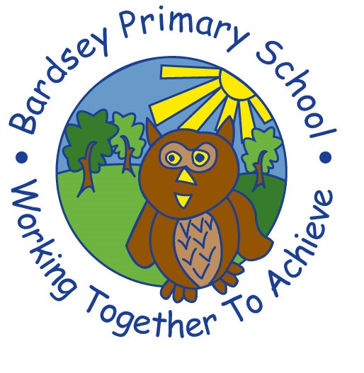
W/C 29.06.2020: Learning Project - FOOD
Age Range: EYFS
Weekly Reading Tasks | Weekly Spelling Tasks
Monday- Listen to the nursery rhyme ‘Hot Cross Buns’ here. Once your child has listened to it a few times, encourage them to sing along. Can they learn the rhyme independently? | Monday- Ask your child to practise writing the sounds which they are currently working on. You can find these on the school website. They can do this with a pencil, chalk, felt tips or anything else you have access to.
Tuesday- Task your child with finding foods in the fridge/cupboard that begin with these sounds: b, s, m, a, p & c. Can they find more than one? | Tuesday- Pour flour, rice or lentils into a shallow tray or plate. Show your child a letter/sound or tricky word and ask them to ‘write it’ in the food using their finger.
Wednesday- Share stories about food e.g. The Gingerbread Man. Look here or here for a range of stories. Ask your child to describe what happened in the story. | Wednesday- Practice the sounds your child is working on here. This can be oral blending (e.g. spoken out loud c-a-t) or written if appropriate.
Thursday- Listen to the story ‘Oliver’s Vegetables’ here. Talk to your child about their favourite foods. Which foods would they like to try that they haven’t tried yet? | Thursday- Think of words to describe different foods - each word should start with the same letter i.e. tasty tomato, spicy spaghetti.
Friday- Look at recipe books and food magazines together. Show your child how each recipe tells you what ingredients you need first. Is there a recipe that you could follow together? | Friday- Play ‘What am I?’. Describe food types to your child and they have to guess what food you are describing e.g. I am yellow. I am a fruit. I begin with the sound ‘b’. I can be peeled.
Weekly Writing Tasks | Weekly Maths Tasks- Describing and Sorting into Sets
Monday- Ask your child to draw the events from ‘The Gingerbread Man’ in order. They could label each picture with words or write sentences about each picture. You can listen to the story here. | Monday- Select some toys and ask your child to pick one and describe it. Can they talk about it’s colour, pattern, shape and size? Repeat this for a different toy. Afterwards, get them to compare the toys explaining similarities and differences.
Tuesday-. Using recipes from books as a guide, ask your child to create their own recipe for their dream meal. They could draw out the ingredients and label them and draw the finished meal. Some children may be able to write a few short sentences as instructions. | Tuesday- Put out a selection of toys/objects you have at home that are similar, e.g. cars, pens and pencils, pieces of fruit, pebbles etc. Thinking about what is the same and what is different, can your child sort them into 2 groups? Ask your child if the objects can be sorted into 2 groups in a different way. CHALLENGE: If your child can sort them into 2 groups, can they try and sort them into three groups?
Wednesday- Look at a range of different packages found around the kitchen. Discuss with your child what makes it stand out. Support them to design a package for a treat of their choice by drawing and labelling. | Wednesday- Sort objects that are similar to each other (look above for ideas) and sort them into groups yourself. Then, show your child the groups you have sorted them into. Can they decide how the objects have been sorted?
Thursday- Can your child complete these sentences: My favourite food is…I like this because...Your child can repeat this activity for other family members. | Thursday (theme)- Look for numerals on packaging you find around the house. Can your child recognise the numerals and count out a matching amount?
Friday- Practice name writing. Can your child write their first name? Middle name? Surname? Do this using a variety of pens, pencils, pebbles, shaving foam, etc. | Friday (theme)- Explore weighing and measuring food on the kitchen scales. Ask, what happens as you place more on the scales?

Learning Project - to be done throughout the week
The project this week aims to provide opportunities for your child to learn more food. Learning may focus on where different foods originate from, what makes a healthy meal, opportunities to cook etc.

- What Food Keeps us Healthy?- Provide your child with a selection of items from your kitchen cupboards. Write the word ‘healthy’ onto one piece of paper and ‘unhealthy’ onto another. Ask your child to sort the food accordingly. Discuss why the food is good for you or bad for you. Look at the Eatwell Plate and explain to your child which foods they should eat a lot of or not very much of.

- Eating 5 a Day- Support your child to create a food diary to record how many pieces of fruit and vegetables they eat in a day. They could write these using their phonics knowledge e.g. p-l-u-m or draw a picture of each item. Ask them to count at the end of each day how many items of fruit and vegetables they’ve eaten. Challenge: Ask your child to count how many pieces of fruit and vegetables they’ve eaten over the course of the week.
- Encourage your child to stay fit and healthy by taking part in a Wake Up, Shake Up game.

- Create a Collage- Ask your child to draw out a number of fruits or vegetables, large enough to fill a piece of A4 paper. Provide them with a selection of colourful packaging or magazines. Can they carefully cut out the colourful pieces and stick them onto their picture to create their very own collage?

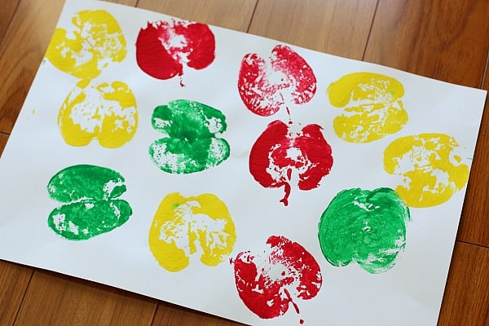
- Shopkeeper Fun- Using toy food or old packaging, set up a food shop for your child to act out being the shopkeeper and customer. You could introduce coins to support their developing knowledge of money. Give them a notepad to use as a shopping list to encourage in the moment writing. This is a great opportunity to practise your child’s speaking and listening skills too.

- Potato Printing- Using a potato, support your child to print and explore the shapes and patterns they can create by printing. Can they make a repeated pattern using two colours? Vegetables such as carrots and peppers will also work for this activity.

