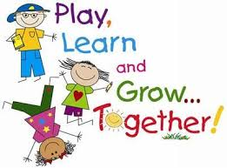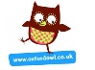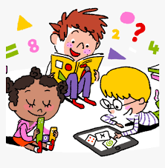

**Year One Home Learning Bulletin -**

**Week Beginning 6th July 2020**

Hello Year One,

It was so good to see both the children who are learning at home and the children who are in school this week. The children who are learning from home all did a fantastic job of writing their recipes. It was clear that you had thought carefully about how to present your work and your finished dishes looked very impressive. This week the theme is Celebrations. Teddy has made his own PowerPoint all about the events he celebrates throughout the year. Watch it and then think about things that you celebrate each month. I am really looking forward to seeing your ideas. You might have to cast your mind back to last year for some of the months as things have been a little different this year! You can present your work in any way you choose.

**Don’t forget:** Try and read at least three times a week, you can read either a book of your choice or one of the many eBooks on [www.oxfordowl.co.uk](http://www.oxfordowl.co.uk) or Collins Big Cat. Make a note of them in your Reading Record book.

Use Spellodrome to help you read and spell words containing this week’s sounds: ‘s’ and ‘es’

Complete the two activities allocated on Mathletics.

**Computing and Technology:**

On Purple Mash this week there is are two tasks that you may like to have a go at. The first one is to design a menorah in the Paint program and the other one is to play a quiz about using coins You will find them both in your 2Dos

Please email your celebrations work and anything else you would like me to see. The Year One email address is:

year1staff@bardseyprimary.org.uk

**Phonics:**

There are daily phonics lessons for Year One Children on YouTube at 10.30 a.m. every morning. To find them follow the link on the letter sent home.The focus for our spellings this week is revision of the tricky words covered in Year One. These are also known as common exception words. There are three quizzes about them in your 2Dos in Purple Mash

Go to [www.newphonicsplay.co.uk](http://www.newphonicsplay.co.uk) Username: march20 Password: home for further practise.

**Learning about Celebrations:**

There are lots of activities relating to celebrations that you could have a go at this week. You could write a diary extract about a celebration that you have taken part in. You could plan a celebration or a party. You could ask other family members about your family celebrations. You could decide to make a celebration card to send to somebody you know. Thinking about celebrations is a great opportunity to look back at some photographs. I bet like me, you have forgotten about some of the events you have enjoyed celebrating.

**Literacy**

Kipper’s Birthday is a lovely story to listen to. Can you explain what Kipper gets wrong? I have recorded two books this week, one is a little non fiction text on the theme of celebrations and the other is all about Hanukkah. Try and think about what you celebrate in time for our Zoom chat on Friday. If you can link your celebrations to the months of the year that would be great. It will be interesting to share all the different events that you celebrate and the ways that you celebrate them.

**Reading**

Read three times this week, selecting either books from home or eBooks at Collins Big Cat or Oxford Owl. To get access go to Collins Connect and click on the teacher portal and enter Username: [parents@harpercollins.co.uk](mailto:parents@harpercollins.co.uk) Password: Parents20! There are a couple of books linked to the theme of celebration in Oxford Owl. You might enjoy Special Days Poems, Christmas Adventure, Happy Birthday Winnie and Dad’s Birthday.

**Maths:**

You will find weekly maths tasks on the theme of Money in this week’s Learning Project.

The links to the White Rose Maths this week can be found in the maths folder on the Home Learning page. The tasks all relate to describing turns and positions.

Don’t forget to go on Mathletics and complete this week’s activities.

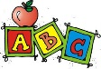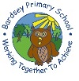

**This week’s spellings to learn are:**

little, one, were, out, people, called, asked, looked, their, could

There are 5 activities relating to these words on the website. You could complete one each day and then do your own test on Friday. This week’s words are a revision of some Year One tricky words. There are two handwriting activities on the website for you to choose from, one on capital letters and the other one using tricky words.

