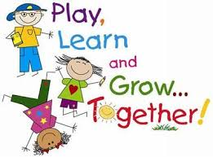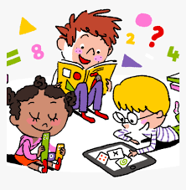

**Year One Home Learning Bulletin -**

**Week Beginning 13th July 2020**

Hello Year One,

Well the last day of the strangest term ever will soon be upon us. I am sure that you are all looking forward to a well-earned break. You have continued to impress me with the enthusiasm that you have all shown. You should feel very proud of the way you have adapted to learning in new ways both at home and at school. I would like to thank both you and your families for all the hard work you have put in to continuing your education despite the difficulties we have all faced. I always knew that it was important for there to be strong partnerships between home and school but it was never more vital than this year. I wish you all a happy and safe summer holiday. I shall greatly look forward to seeing you all back at school in September.

**Don’t forget:** Try and read at least three times a week, you can read either a book of your choice or one of the many eBooks on [www.oxfordowl.co.uk](http://www.oxfordowl.co.uk) or Collins Big Cat. Make a note of them in your Reading Record book.

Complete any outstanding activities allocated on Mathletics.

**Have a lovely summer holiday!**

**Our Zoom Meeting on Friday**

Don’t forget to find something fun to dress up in. I can’t wait to see you. Teddy and I have our outfits ready!

Please email me any of your work about transition that you have completed this week. I am particularly looking forward to reading about the 5 goals you have set for yourself, which I will be able to pass on to Miss Morrison. The Year One email address is:

year1staff@bardseyprimary.org.uk

**Phonics:**

There are daily phonics lessons for Year One Children on YouTube at 10.30 a.m. every morning. To find them follow the link on the letter sent home. There are no new spellings to learn this week. For those of you keen to keep up your phonics skills over the summer There are copies of the Phase 3 and Phase 5 sounds in the weeks folder. It is good to be familiar with them preparation for Year 2. Go to [www.newphonicsplay.co.uk](http://www.newphonicsplay.co.uk) Username: march20 Password: home for further practise.

**Learning about Transitions**

This week we are reflecting on the year that is over as well as considering the new school year ahead. It is bound to be a time of excitement and uncertainty. This year has been like no other and for the children (and teacher!) who have been away from school all these months, moving into a new class may be daunting. Please be reassured that the staff are very aware of this and we will all be working together to make things as smooth as possible for everyone in September. Please get in touch if we can help in any way.

**Literacy**

Listen again to the story Giraffes Can’t Dance on the Year One Home Learning Page under Read Alouds and then think about what you would like to achieve when you are in Year Two. Try and think of 5 things that you would like to work on during the next school year. Have your ideas ready for our Zoom chat on Friday. I have provided a paper format if you would like to write down your ideas for Mondays Memory Jar task. If you decide to do Tuesdays task, there is a paper format that you could use on the website too.

**Reading**

Read three times this week, selecting either books from home or eBooks at Collins Big Cat or Oxford Owl. To get access go to Collins Connect and click on the teacher portal and enter Username: [parents@harpercollins.co.uk](mailto:parents@harpercollins.co.uk) Password: Parents20!

Try and keep up with your reading during the summer. Have a look at [www.summereadingchallenge.org.uk](http://www.summereadingchallenge.org.uk) to find out more about the Leeds Libraries summer reading challenge.

**Maths:**

You will find weekly maths tasks on the theme of Time this week in the maths folder on the Home Learning Page.

The accompanying video clips can be found by going to <https://whiterosemaths.com/homelearning/year-1/>

Don’t forget to go on Mathletics and complete any activities that you haven’t yet done.

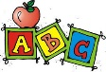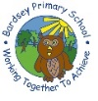

**This week’s spellings to learn are:**

There are no new spellings to learn this week. However, I have put a copy of the Year One Common Exception words (We would call them tricky words) so that you can check how many of them you can read and write. Knowing them and being able to write them accurately will greatly help you in your reading and writing when you get into Year Two.

